RAM Commander Licensing
You have successfully installed RAM Commander. Now you have to initiate your RAM Commander license.
To initiate your RAM Commander license, do the following:
- Click the Start menu, choose Programs and then A.L.D. Engineering.
- Run the LicenseMngr program. The following dialog box appears:
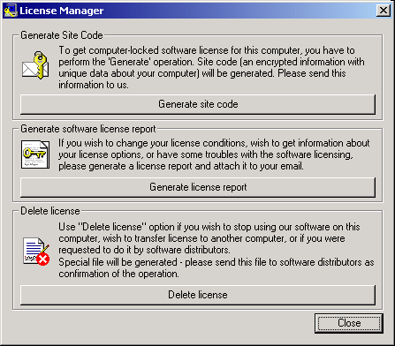
- Click Generate site code. You will receive a message providing you with the file name containing your site (computer) code.
- Send this file to: rafi@ald.co.il and c.c.: raya@ald.co.il. Please write also your full name, company name and contact information.
- You will receive an e-mail containing your RAM Commander license file.
- Save your license file to RAM Commander installation folder, BIN subfolder (usually C:\RAMC32\BIN).
- Run RAM Commander.
Do not hesitate to contact us if you have any questions: support@ald.co.il

Hardware/Software changes
If you plan to change software (Operating System) or hardware (whole computer or hard drive or motherboard or processor) on the computer where RAM Commander is installed, you should delete your license before, sending us the license delete confirmation file – see instructions below.
After the changes are completed, you should repeat the site code generation process (see “To initiate your RAM Commander license” part of this document).

To delete your RAM Commander license, do the following:
- Click Start menu of your PC, choose Programs, then the "A.L.D. Engineering"
- Run LicenseMngr program.
- Click "Delete license". You will receive the message providing you with the file name containing your license delete confirmation file.
- Send this file to: rafi@ald.co.il, c.c.: raya@ald.co.il and we will register that you license is deleted – then you will be able to get a new license file instead of the deleted one for another computer or another system configuration later.
To send report about your RAM Commander license, do the following:
- Click the Start menu, choose Programs and then A.L.D. Engineering.
- Run the LicenseMngr program.
- Click "Generate license report". You will receive the message providing you with the file name containing your license report file.
- Send this file to us together with problem description and your full name, company name and contact information.

